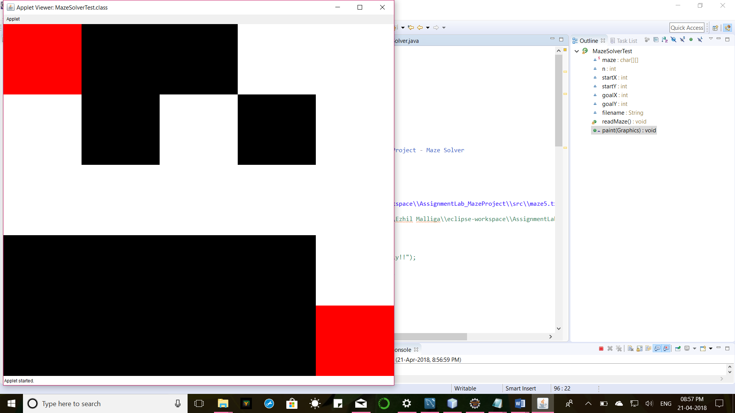

**import** java.applet.Applet;

**import** java.awt.Color;

**import** java.awt.Graphics;

**import** java.io.BufferedReader;

**import** java.io.FileNotFoundException;

**import** java.io.FileReader;

**import** java.io.IOException;

**import** java.util.Scanner;

/**

**@author** Govind Yatnalkar & Kanimozhi Kalaichelvan

* **@Marshall** ID: 901-87-5614, 901881363

* **@date**: 04/01/2018

* **@CS580** Advanced OOPS Programming Assignment - JAVA Project - Maze Solver

*/

**public** **class** MazeSolverTest **extends** Applet{

**static** **char**[][] *maze*;

**int** n, startX, startY, goalX, goalY;

String filename="C:\\Users\\Ezhil Malliga\\eclipse-workspace\\AssignmentLab_MazeProject\\src\\maze5.txt";

// public void paint(Graphics g) {

// MazeSolver myMaze = new MazeSolver("C:\\Users\\Ezhil Malliga\\eclipse-workspace\\AssignmentLab_MazeProject\\src\\maze5g.txt");

// myMaze.readMaze();

// myMaze.paint(g);

//// myMaze.solveMaze();

// if(myMaze.solveMaze(g))

// System.out.println("Maze Solved Successfully!!");

// else

// System.out.println("Maze Not Solvable...");

// }

**public** **void** readMaze() {

**try**

{

FileReader fr = **new** FileReader(filename);

BufferedReader br = **new** BufferedReader(fr);

n = Integer.*parseInt*(br.readLine());

*maze* = **new** **char**[n][n];

**for**(**int** i = 0; i < n ;i++)

{

String s = br.readLine();

**for**(**int** j = 0; j< n; j++)

{

*maze*[i][j] = s.charAt(j);

**if**(*maze*[i][j] == 'S')

{

//Code to get start coordinate

startX=i;

startY=j;

}

**if**(*maze*[i][j] == 'G')

{

//Code to get the end coordinate

goalX=i;

goalY=j;

}

}

}

}

**catch**(FileNotFoundException e)

{

e.getMessage();

e.printStackTrace();

System.***out***.println("File Not Found");

}

**catch**(IOException e) {

e.getMessage();

e.printStackTrace();

System.***out***.println("Invalid Entry");

}

}

**public** **void** paint(Graphics g)

{

readMaze();

System.***out***.println();

**int** k= **this**.getHeight()/n;

**int** l= **this**.getWidth()/n;

**for**(**int** i = 0; i < n ; i++)

{

**for**(**int** j = 0; j < n ; j++)

{

**if**((*maze*[i][j]=='S')||(*maze*[i][j]=='G'))

{

g.setColor(Color.***RED***);

g.fillRect(i*l,j*k,l,k);

}

**if**(*maze*[i][j]=='#')

{

g.setColor(Color.***BLACK***);

g.fillRect(i*l,j*k,l,k);

}

**if**(*maze*[i][j]=='.')

{

g.setColor(Color.***WHITE***);

g.fillRect(i*l,j*k,l,k);

}

System.***out***.print(*maze*[i][j]);

}

}

}

}